Employee – Self Service User

You will shortly receive an email from support@bluemarblepayroll.com that will give you access to viewing your payslips and other stored personal details online.

This portal can be accessed from any location and on the majority of mobile devices.

The below step guide will take you through how to access, and some of the functions available once logged-in.

Step 1 – Setting a Password
Click on the link on the email that you will receive, this will take you to the below screen.

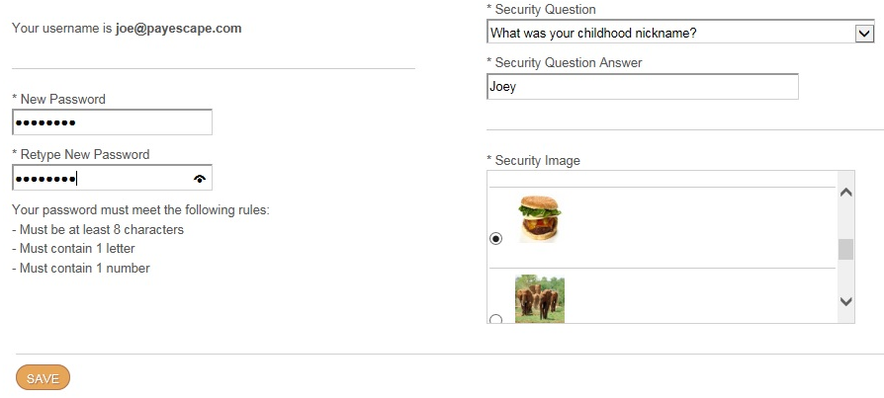

In here you will need to assign yourself with a password and select a security question and image for use should you ever forget your password.

Once you have completed this screen you will need to click on the ‘Save’ button to progress.

Step 2 – Login

Now that you have successfully assigned yourself with a password, you will need to enter your email address and password into the main login screen below.
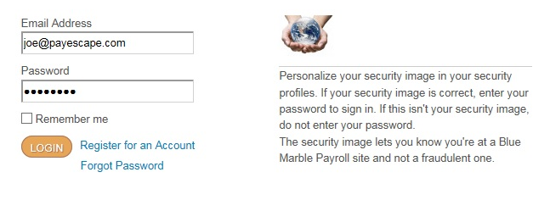
We would recommend that you save this web link for future access for viewing payslips.

If you forget your password you can click on the ‘Forgot Password’ link to reset or contact your local payroll administrator if you are having any other technical problems.

Step 3 – Main Screen

Now that you are logged-in, you will now be on the main screen like the below.

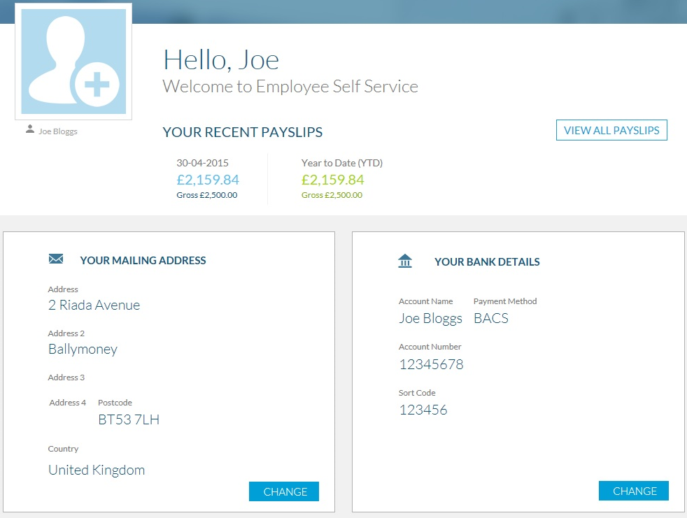

In here you can view your payslips, address and bank details (if applicable) held by the company on your behalf.

Depending on the user rights assigned by the administrator, you will be able to submit amendments to your home address and bank details for approval and future use.

There is a banner at the top of the page where the company can display any news relevant to each employee.

Step 4 – Payslips

There are a couple of ways of viewing your payslips.
If you click onto the latest values (see below) it will bring up the latest payslip for you to review and print if required.
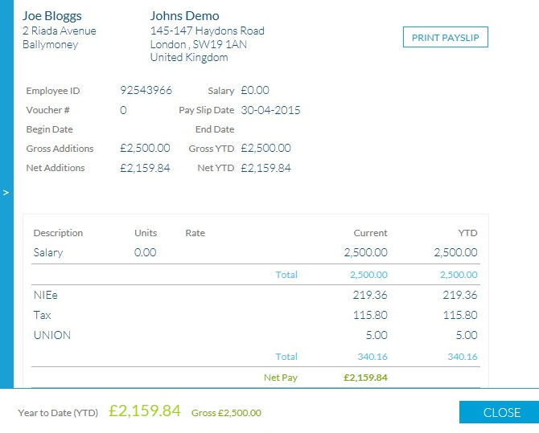
The other option is to click on the ‘View All Payslips’ button on the main screen which will list all available payslips for you to select and view the required on online and print if required.

Step 5 – Amending Personal Details

Depending on user access rights, you can amend your address and bank details from this screen for your payroll administrator to approve for future use.

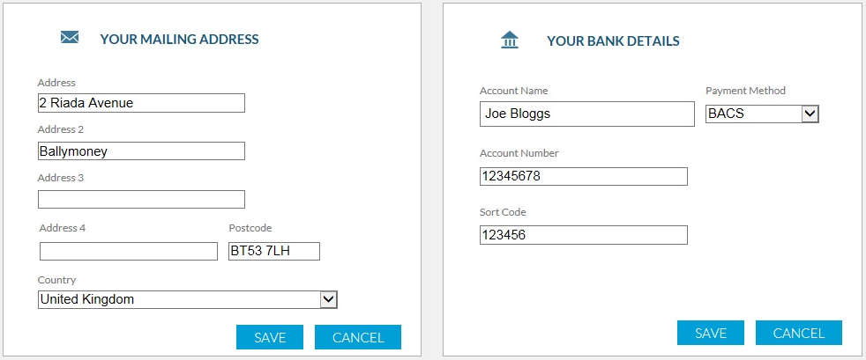

You would simply enter in the new details into the required fields and click on the ‘Save’ button.

Once saved, the pending information will be sent to the administrator to approve.

If you have any queries or concerns, please contact your local payroll administrator.

